For Sale Offers invited

TRIUMPH TR6 TROPHY 1971 AKE46J

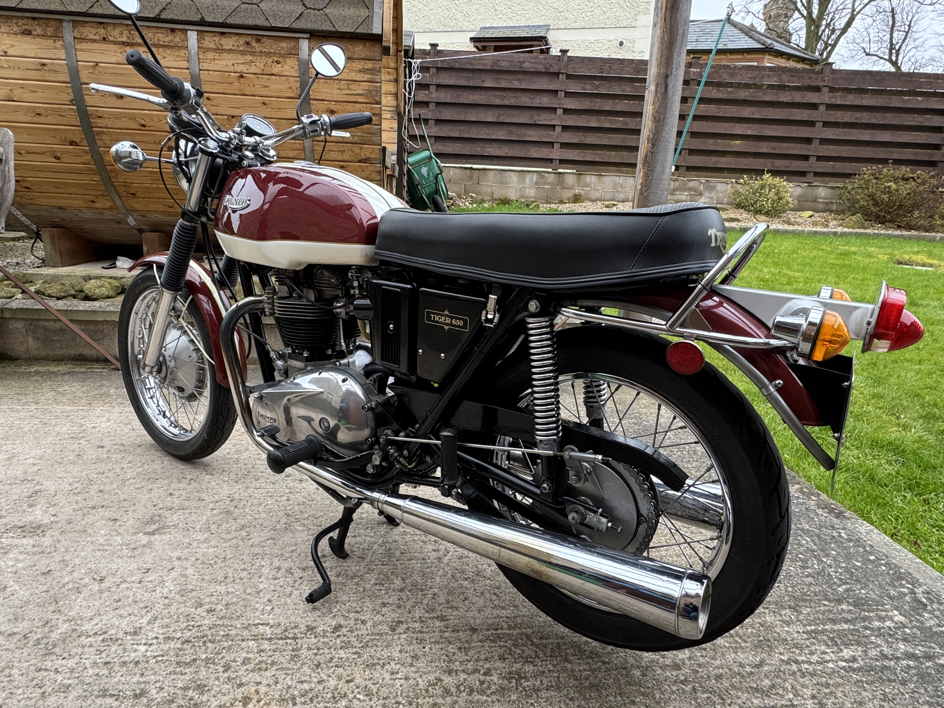
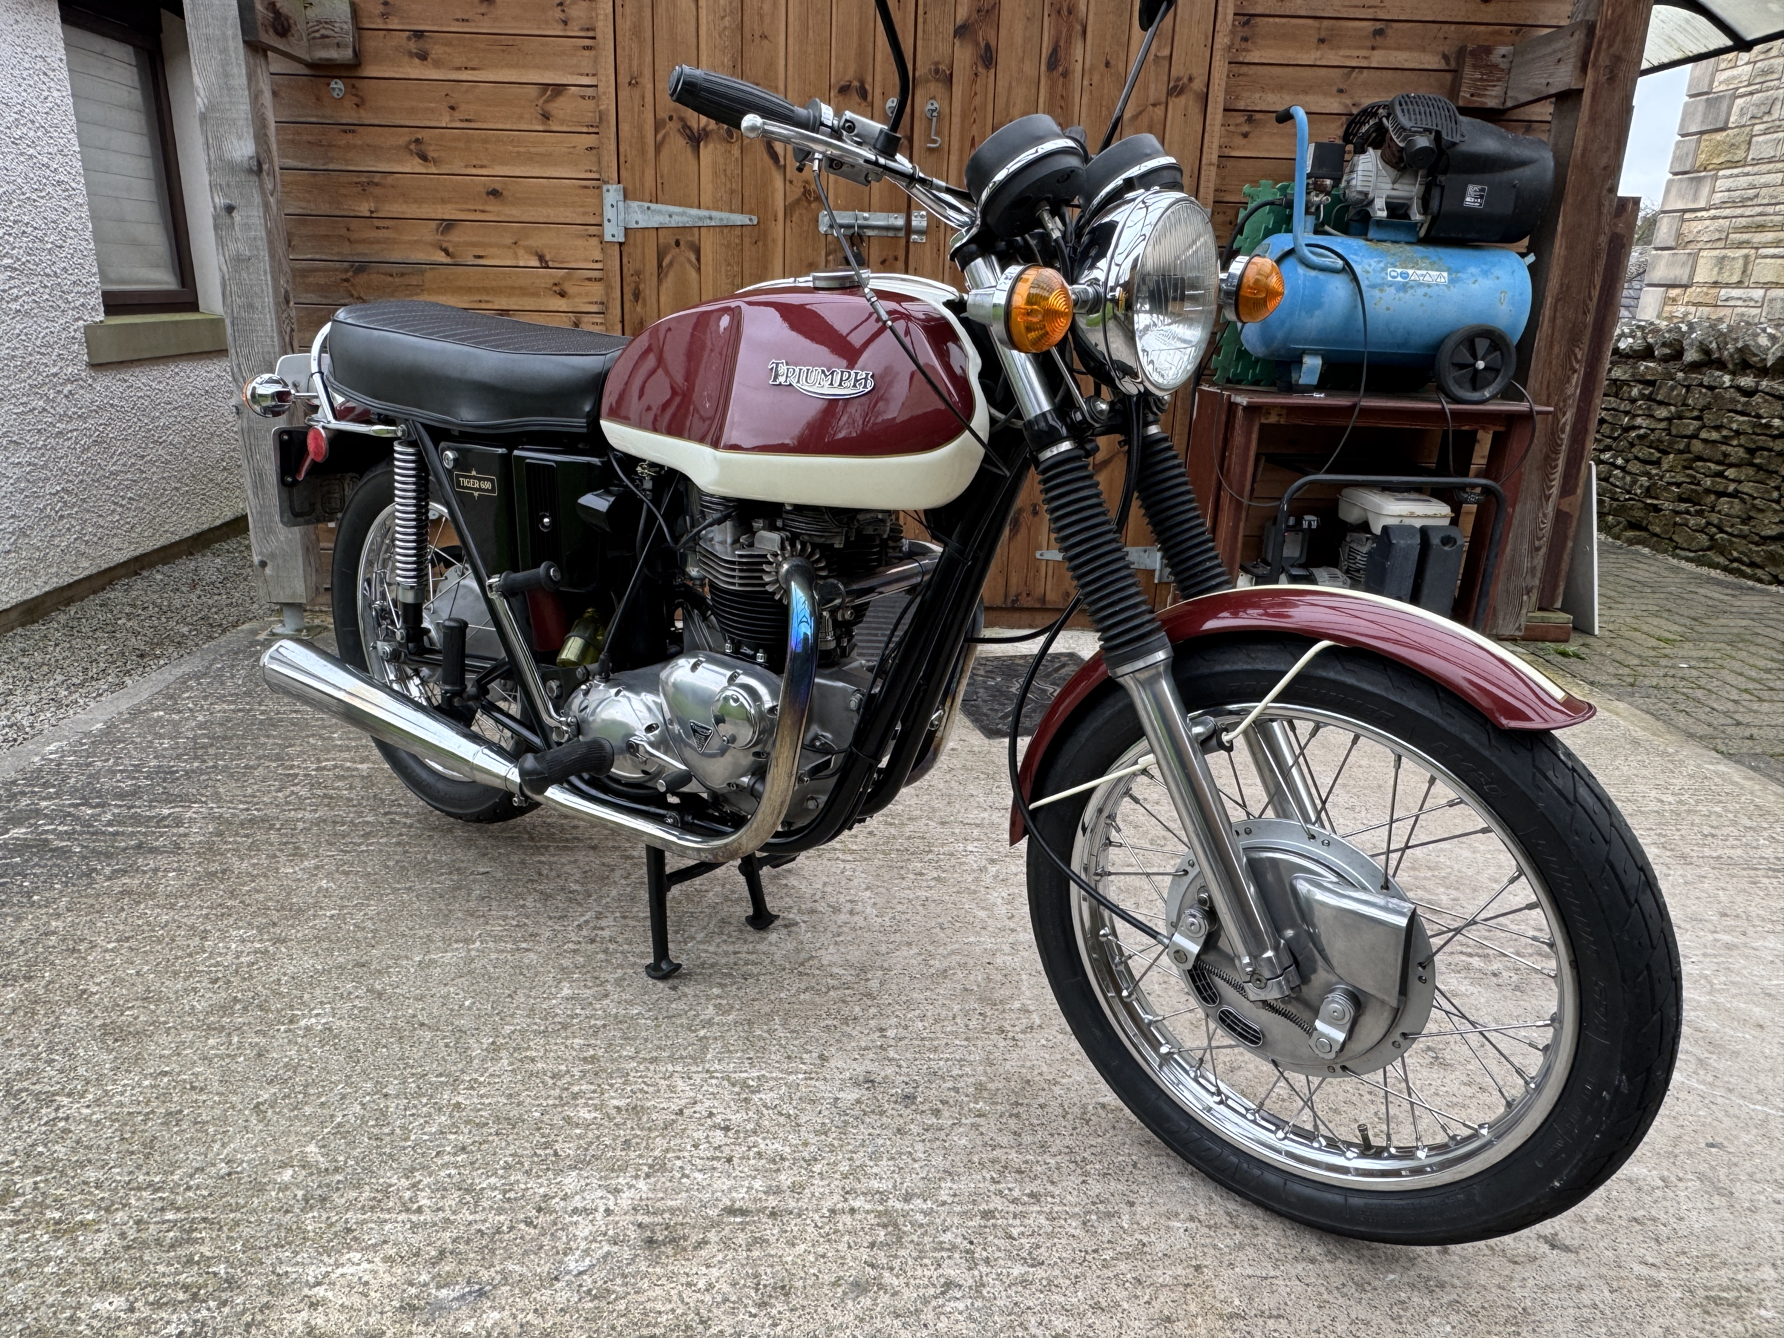

Acquired the vehicle 5 years ago, and purchased from a restoration expert in Alston just 600 miles after a complete engine refresh/ rebuilt, including crank grind/ balance & +20 rebore, all new engine and gearbox bearings, refreshed clutch, and new alternator stator. The engine is very smooth & mechanically quiet and has now covered further 3000 miles mainly on VMCC events.
The bike has had 6 previous UK owners.
The bike has been meticulously maintained by me, with regular oil & filter changes with all maintenance logged in detail. The previous owner did some excellent upgrade modifications at rebuild, including detent plunger to gearbox selector quadrant, electronic ignition, Morgo high flow oil pump, and Cartridge oil filter conversion. The cylinder head also has proper exhaust stubs fitted with the appropriate pipes, as opposed to the poor push in variety in original specification. It has recently had new drive chain with one tooth higher gearbox sprocket to increase overall gearing and cruising comfort.

The bike was originally exported to Baltimore USA, and was re-imported to UK in 1997 where it was attributed an age related registration. It also has historic status, so no tax or MOT requirement. This matching numbers bike was originally a T120V Bonneville, but was converted to single carb TR6 Trophy spec whilst in USA. The bikes build date, numbers and provenance have been verified by original Triumph factory records held by the VMCC library.

This bike would have originally been in Bonneville Gold and white colour scheme, but has been re-painted at some point in an attractive Maroon and off white colour scheme; All tinware and paint is in very good condition, apart from some repainting around the fuel taps where there has clearly been some leaky tap seals in the past - no longer the case with new taps fitted. The motorcycle is not in concours condition, but is very good cosmetically, and in excellent condition mechanically with everything operating as it should. The chrome on the silencers is now showing some age, and could benefit from replacement at some future date.

Ron Maul
Appleby
07484 313982

